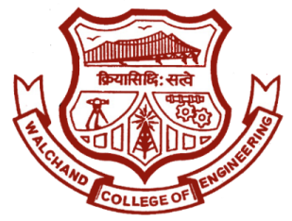

WALCHAND COLLEGE OF ENGINEERING, SANGLI

**ELESA**

**ELECTRONICS ENGINEERING STUDENTS’ ASSOCIATION**

Email: [walchand.elesa@gmail.com](mailto:walchand.elesa@gmail.com) Website: [www.elesa.co.in](http://www.elesa.co.in)

DATE:

To,

_________________

_________________

_________________

**SUBJECT:** Invitation for the mega-event **“ELECTROVERT”** of Electronics Department of WCE, Sangli.

Respected Sir/Madam,

**EL**ectronics **E**ngineering **S**tudents’ **A**ssociation of Walchand College of Engineering, Sangli is organizing a two day technical mega event **‘ELECTROVERT’** on 8th and 9th September 2018.

**ELECTROVERT** comprises of many different engineering fields. It will surely help the students in not only developing their technical skills, but also in dynamically shaping their personalities.

So, to make this event a grand success we will be happy to have you for the inauguration ceremony. Following are the details for Inauguration Ceremony.

Date: 08 September 2018

Time: 09:00 AM

Venue: Tilak Hall

Regards,

ELESA